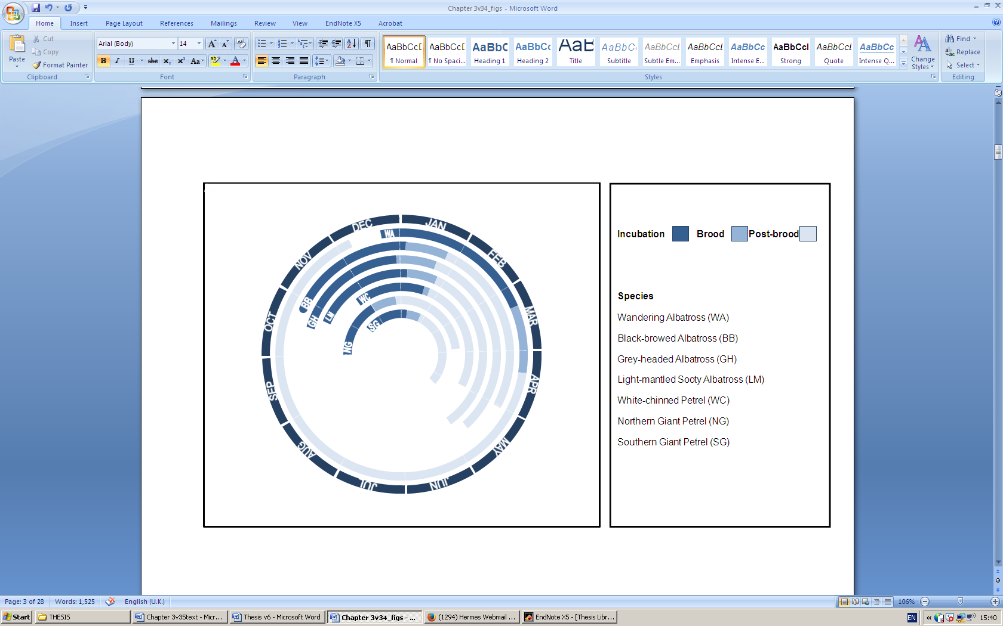

Supplementary figure : Breeding calendar of seven tracked seabird species based on mean dates from field observations recorded in the last two decades at South Georgia

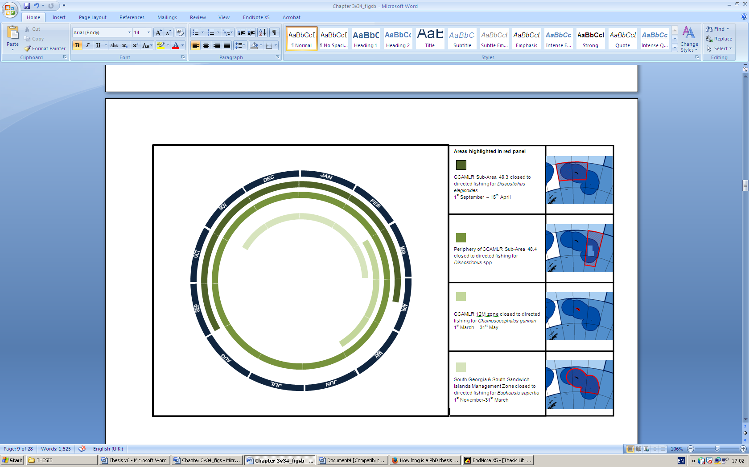

Supplementary figure 2: Seasonal closures of fisheries around South Georgia

EEZnotAntarctica.jpgEEZnotAntarctica.jpgEEZnotAntarctica.jpgEEZnotAntarctica.jpg

D

C

B

A

EEZnotAntarctica.jpgEEZnotAntarctica.jpgEEZnotAntarctica.jpgEEZnotAntarctica.jpg

H

G

F

E

EEZnotAntarctica.jpgEEZnotAntarctica.jpgEEZnotAntarctica.jpgEEZnotAntarctica.jpg

L

K

I

J

EEZnotAntarctica.jpgEEZnotAntarctica.jpgEEZnotAntarctica.jpgEEZnotAntarctica.jpg

M

N

O

P

N

M

EEZnotAntarctica.jpg

Q

Supplementary figure 3: Overlap of important areas with existing management regimes